

8/5/2022

Sumit Mishra

SIC: 190310286

Project-02

Migrating an On-premises server to AWS.

(On-premises server is taken to be a server in a different AWS region for this project.)

# Creating an On-premises server in a different region.

1. Creating an EC2 instance inside a custom VPC with subnets, internet gateway enabled.

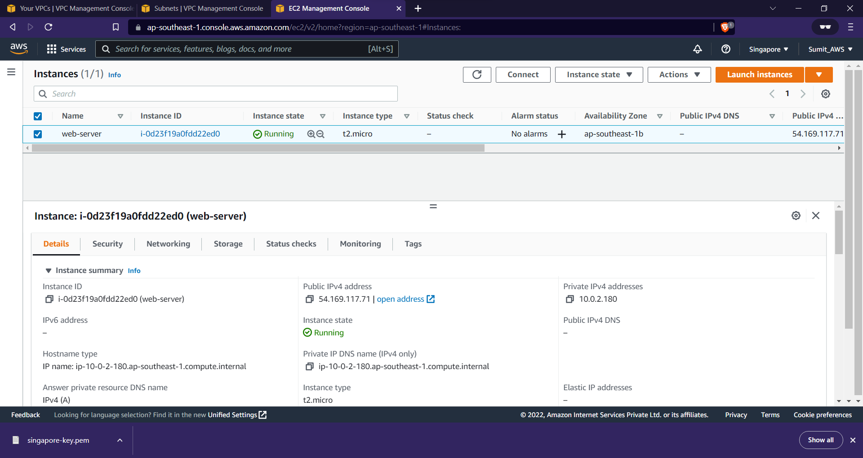



1. Connecting to the EC2 instance and downloading/installing Apache server in it.

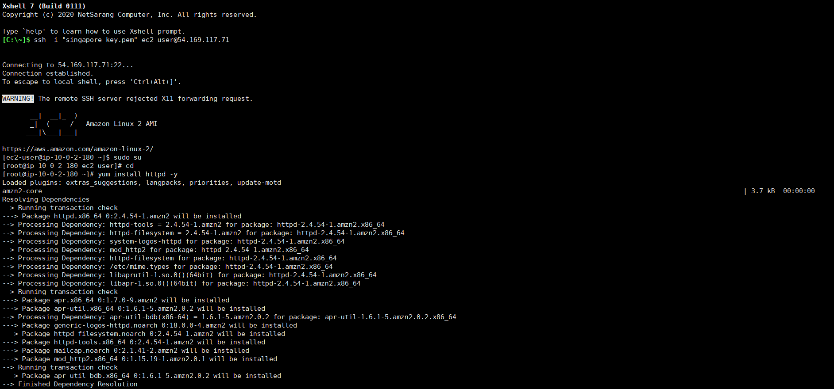

1. Putting some sample website to display.

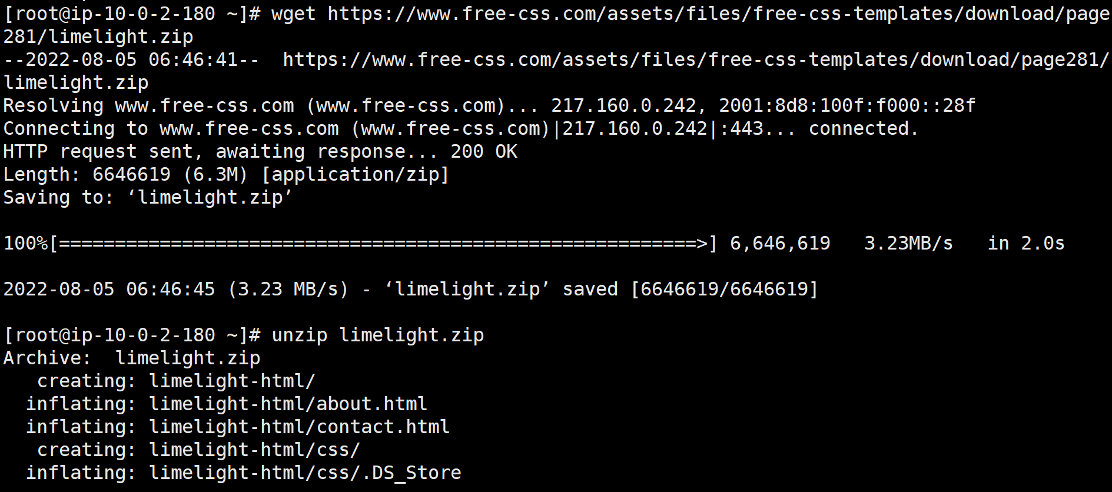

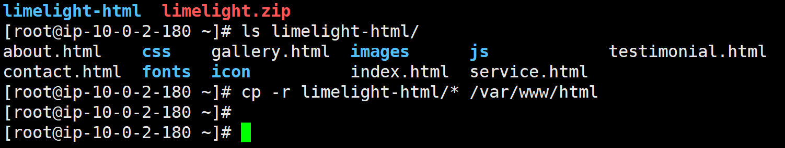

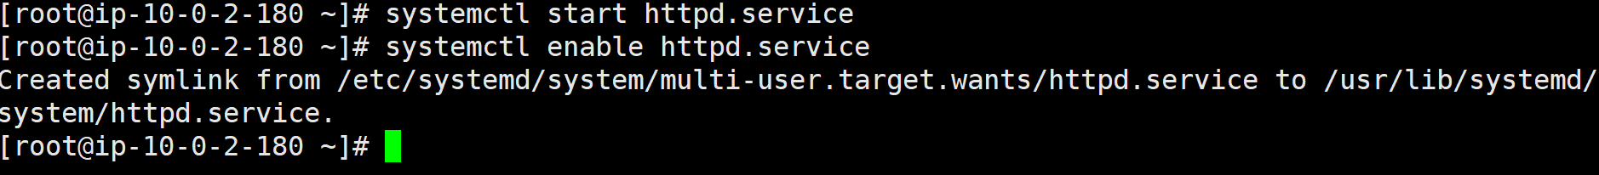



# Migrating the server On-premises to AWS (i.e., from Singapore region to Mumbai region).

1. Set up application migration service and create template.

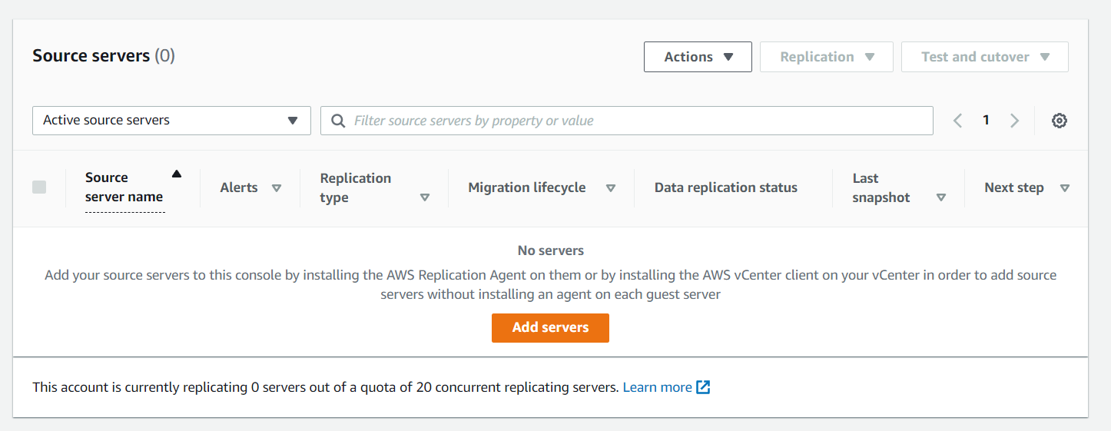

1. Adding server configuration for migration.
   * + 1. Creating an IAM role for server migration.

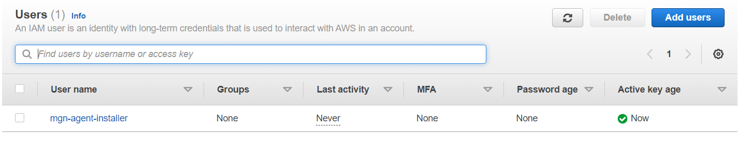

* + - 1. Provide the details of the IAM user.

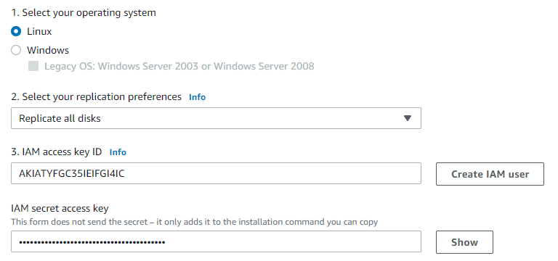

* + - 1. Download the installer using the copied command.

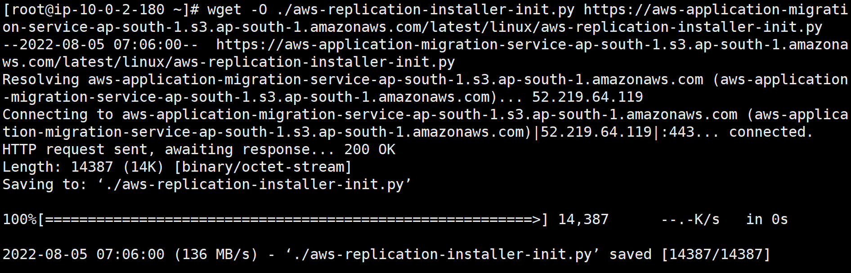



* + - 1. Download the replication agent using the copied command.

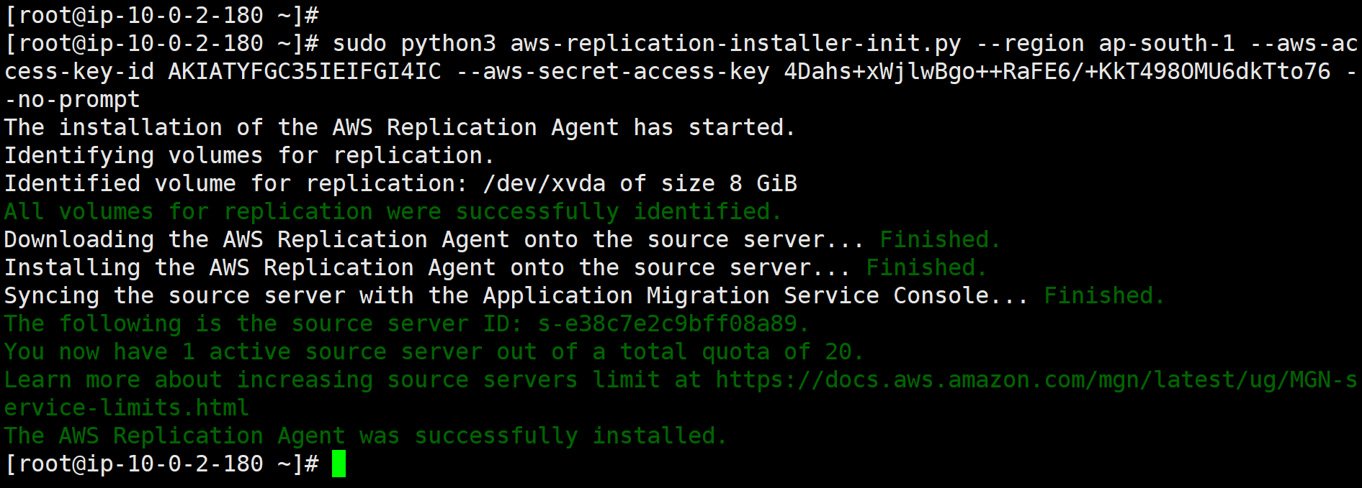



1. After adding source server to the migration service, wait for the replication to complete.

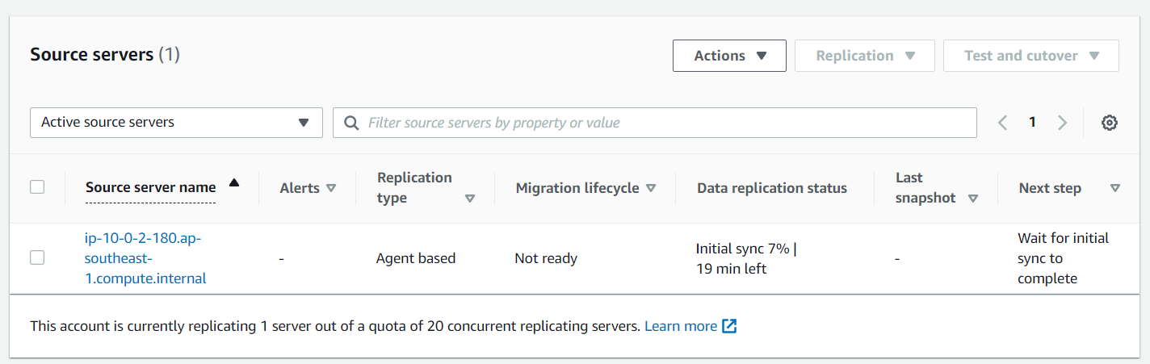

1. After the replication completed, I launched the test instance as specified in the next step.

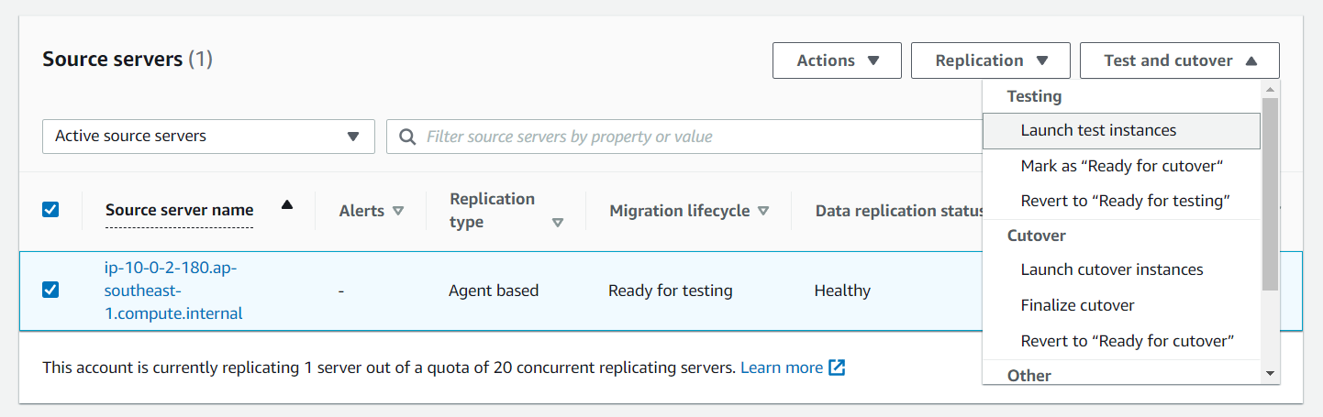

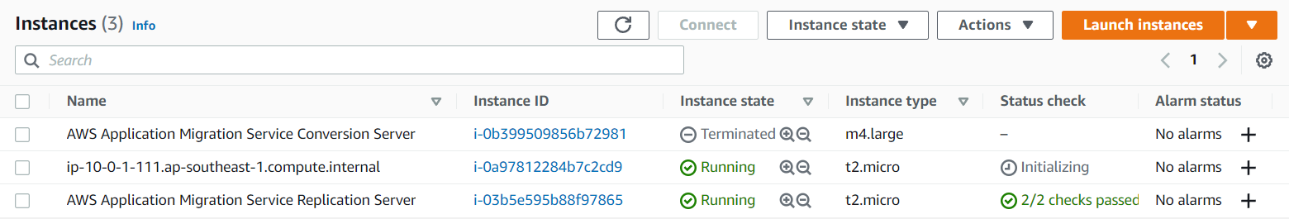

The launched test server reflected on the EC2 console.

1. Tested using the public IP of ip-10-0-1-111.ap-southeast-1.compute.internal instance to check if conversion was properly completed or not.



As the website was able to host on the public IP, I concluded that the conversion had been done properly.

1. After testing was successful, I marked the server as “ready for cut-over” as was mentioned in the next step column.

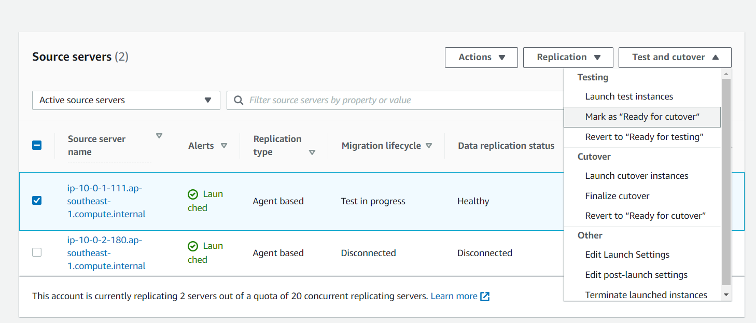

1. After I marked the server as “ready for cutover”, I then launched cutover instances as was mentioned in the next step.

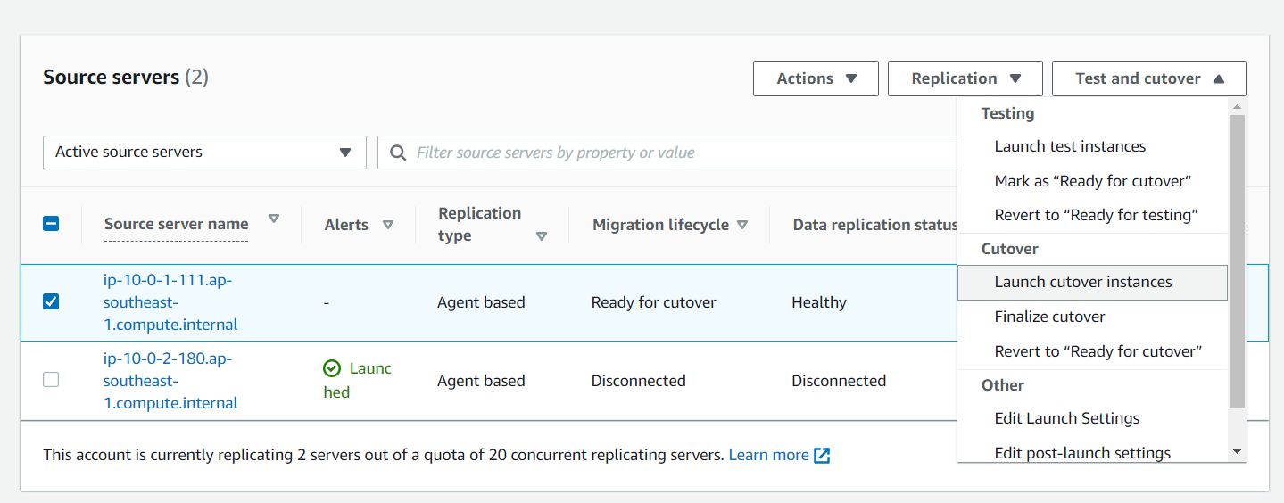

I tested the cut-over server and it worked fine.

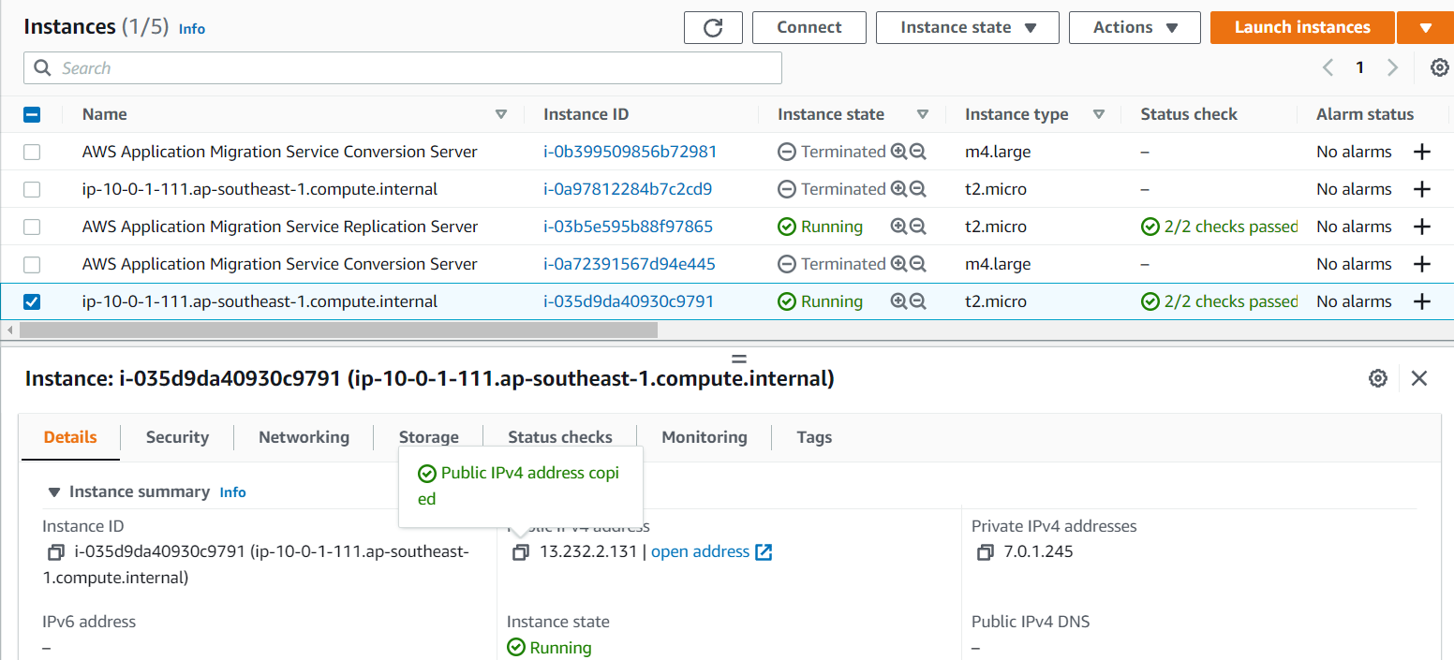



1. After testing the cut-over instances, I finalized the cut-over as was mentioned in the next step.

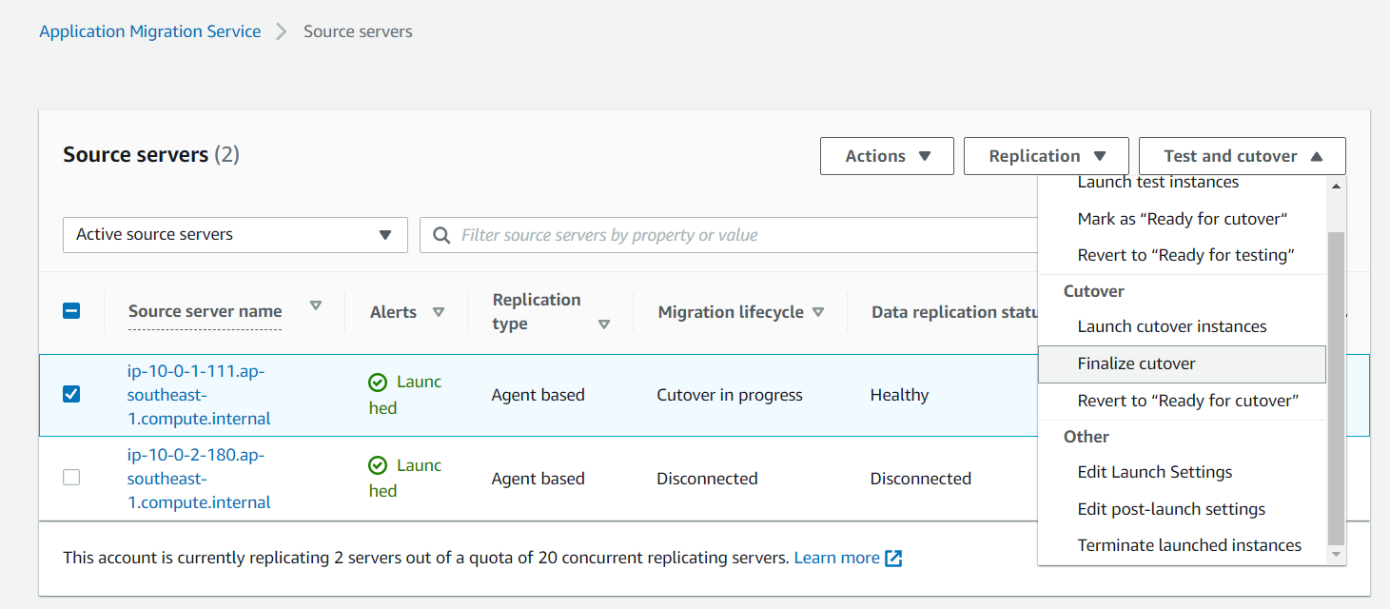

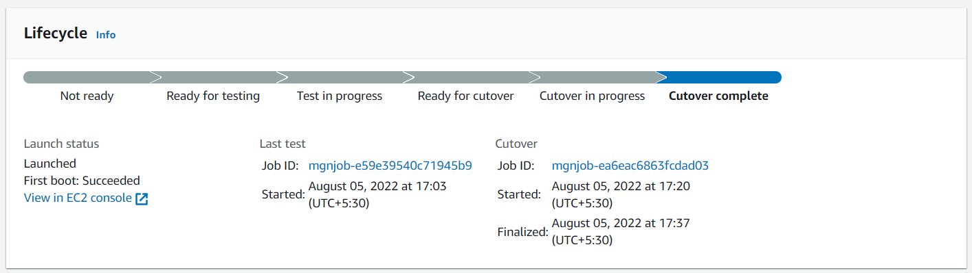

1. After the cut-over was completed, I was marked the server as archived as was mentioned in the next step column.

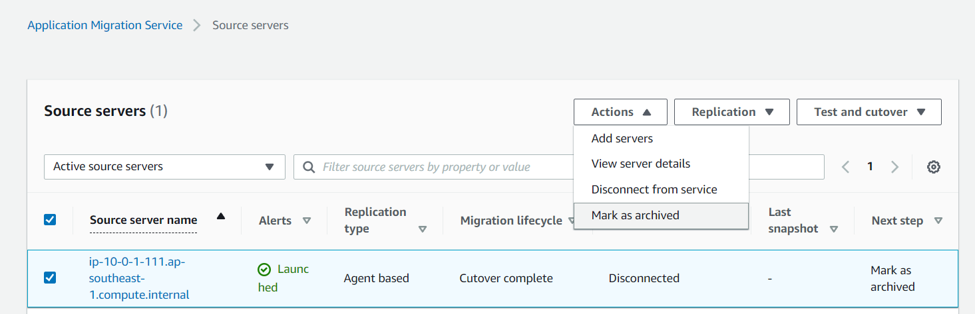

Now, Mumbai region also has the exact copy of the web-server present in Singapore, so server migration was successful from on-premises to AWS.